**SCHOOL**

USER guide

|  |  |  |
| --- | --- | --- |
| Supervisor: | Sir Minhaj Tahir Khan | |
| Batch: | 2407E1 | |
| Serial no: | Student Id: | Student Name: |
| 01 | Student1583705 | FALAH KHAN |
| 02 | Student1586491 | AYESHA |
| 03 | Student1584626 | HANIA RASHEED |
| 04 | Student1586477 | AHSAM SAEED |
| 05 | Student1518113 | SHAHRUKH KHAN |

THE KNOWLEDGE OF ARK

Home (homepage.html)





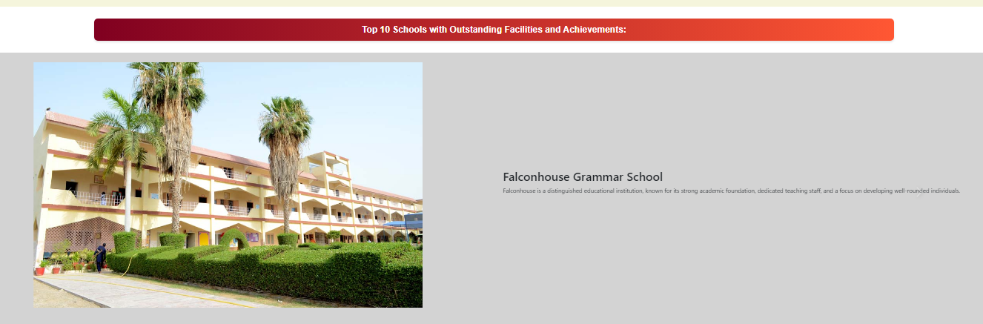

Coding of homepage.html

Footer(Footer.html)



Navbar: (Navbar.html)



Contactpage(Contact.html)

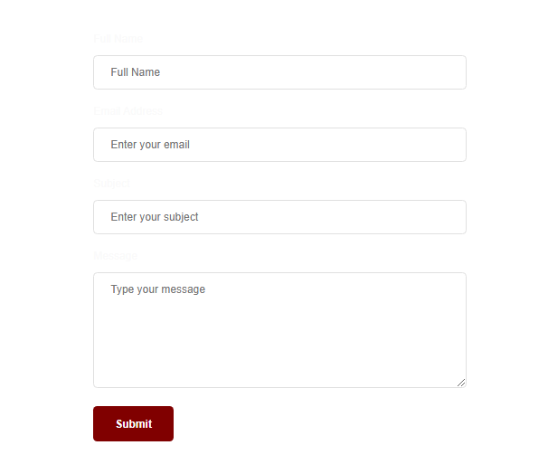

Aboot us (aboutus.html)

